Ways To Secure a Website

Introduction

More businesses and individuals are using the World Wide Web (WWW) as a cost-effective,
efficient means of disseminating information, goods, and services. There is no built-in security
on the internet. The security of the data is a critical issue that needs to be addressed despite all
the advantages the internet may offer. Electronic fraud is a concern for businesses that want to
allow customers or clients to place orders online, especially if they plan to send sensitive data
over the internet like financial transactions, credit card numbers, and trade secrets.
We now take secure websites for granted in our daily lives. People use these websites to carry
out both personal and professional transactions. Security is a top priority on these sites because
of their sensitive nature. They all use protocols like SSL, and many of them employ security
professionals to perform vulnerability analyses.

1. Installing a security socket layer:

Using HTTPS, a protocol that enables sending secure communication over a computer network
and guarantees that no outsider will be able to access one&#39;s content, is the best way to add a
socket layer (SSL) to the website. This indicates that website visitors will be able to browse
safely while providing their personal or financial information, such as login information, in a
secure manner. For this reason, websites must use HTTPS. (Bocetta, S. 2021)
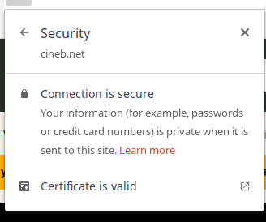

Figure 1: fig: security socket layer

2. Implementation of Firewall

Any security design must include a firewall because it gives your network security device control
over host level defenses, taking the guesswork out of it. Next Generation Firewalls in particular
focus on stopping malware and application-layer attacks with the aid of an integrated intrusion
prevention system (IPS). These Next Generation Firewalls are capable of detecting and
retaliating to external attacks across the entire network with lightning-fast efficiency. They can
put policies into place to better safeguard your network and conduct quick analyses to identify
and stop suspicious or intrusive activities like malware. (Wallarm, wallarm)

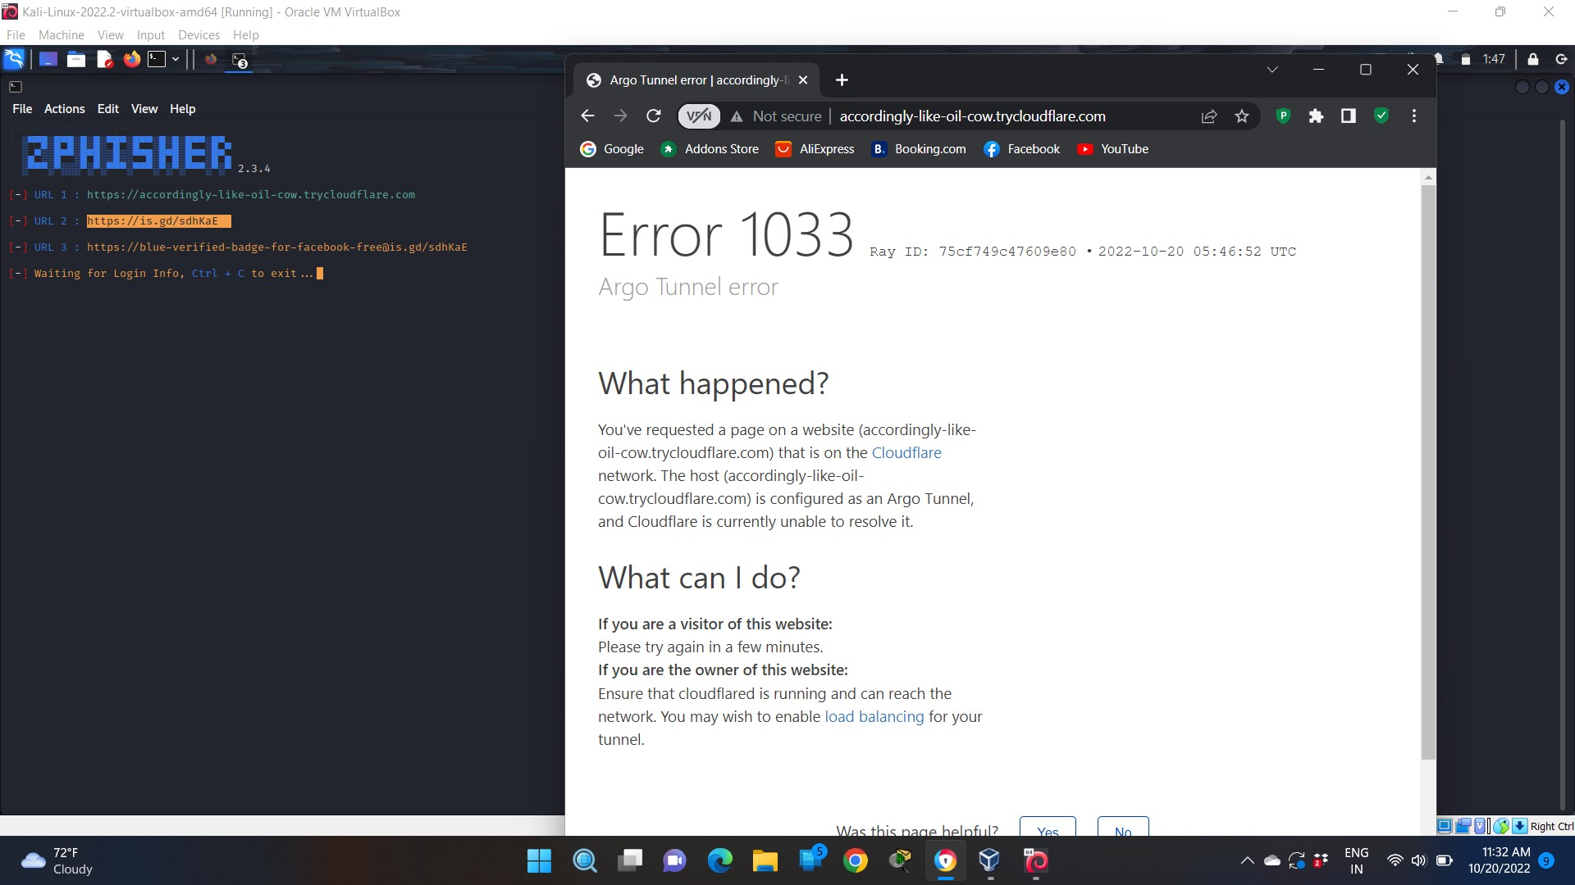
Figure 2: Firewall

3. XSS (cross-site scripting) attack defense:

Cross-site scripting (XSS) attacks insert or inject malicious JavaScript into the web pages, which
can change the contents of the web pages or steal data and transmit it back to the attacker. For
instance, if comments are displayed on a webpage without being validated, an attacker could post
comments with script tags and JavaScript, which could run in other user’s browsers and steal
their login cookies, giving the attacker control of every user who saw the comment. Therefore, it
is important to make sure that users cannot insert active JavaScript content into web pages. (Bocetta, S. 2021)

Simple reflected XSS vulnerability illustration:

https://insecure-website.com/status?message=hello+my+mate.

<p>Status: hello my mate</p>

The application doesn’t perform any other processing of the data, so an attacker can easily
construct an attack like this:

https://insecure-website.com/status?message=<script>/*+Bad+stuff+here...+*/</script>;
<p>;Status: <script>/* Bad stuff here... */</script></p>

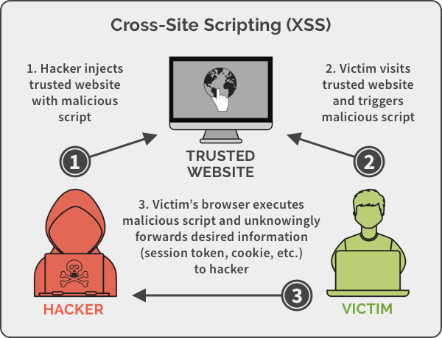
Figure 3: Cross Site Scripting

4. SQL injection prevention

A parameterized query, which is easy to implement because most languages have it, should be
used to prevent this from happening. An example of a typical query would be this.
“SELECT * FROM table WHERE column - ‘ “ + parameter + “ ‘ ;

This is how the query would appear if an attacker changed the URL parameter to pass in ” or “1”= ”1:

“SELECT * FROM table WHERE column = “OR ‘1’=’1’;”

It should be parameterized to prevent an attacker from appending a query to the end of this
statement. This can be accomplished by altering it to resemble this.

$stmt = $pdo prepare(‘SELECT * FROM table WHERE column = :value’); $stmt->execute(array(‘value’ => $parameter))

The number of infected websites increased by 32% between 2015 and 2016. Because of this,
immediate action is required, and preventing SQL Injections should be one of the first security
measures taken. (Wallarm, wallarm)

Conclusion

Several attacks were conducted to test the security of a website in the report mentioned above.
Attacks like SQL injection, HTTPS port attack, cross-site scripting, and finally firewall attacks
were carried out. However, due to the website&’s high level of security, only SQL injection and
cross-site scripting were successful attacks. The firewall could not be penetrated which ensures
the high security of the website. In these ways 4 ways for keeping a website safe is illustrated.

References

Bocetta, S. (2021) 6 simple ways to protect your website from attackers, Acunetix. Acunetix. Available at: https://www.acunetix.com/blog/ (Accessed: October 19, 2022).
Wallarm, wallarm (no date) What is a Firewall? definition and how does it works? ️, Firewall. Available at: https://www.wallarm.com/what/ (Accessed: October 21, 2022).

